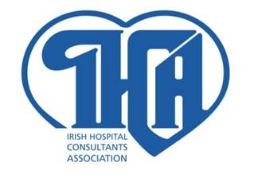
IRISH HOSPITAL CONSULTANTS ASSOCIATION

HERITAGE HOUSE TELEPHONE: 298 9123
DUNDRUM OFFICE PARK FAX: 298 9395
DUBLIN 14 E-MAIL: info@ihca.ie
WEB: www.ihca.ie
16th May 2012

PRESS RELEASE

The Irish Hospital Consultants Association met the HSE and the Department of Health today (Wednesday) to discuss the implementation of the Public Service Agreement.
The IHCA pointed out that consultants are working well beyond their contract hours and providing a very flexible service to respond to the urgent and unpredictable needs of patients on the weekends and outside normal hours.
Consultants are leading the implementation of the new Clinical Care Programmes and other developments that are giving rise to significant increases in health service productivity and savings. Over the past few years, consultants have treated a significantly increased number of patients with reduced resources through improved programmes.
The IHCA said it is important that the new programmes are provided with the resources to achieve their potential. It said that the restructuring of service delivery and the realignment of scarce resources to frontline hospital services is important to treat the increased number of patients presenting for hospital care.
Further meetings will take place in the coming weeks to consider the proposals that fall within the terms of the Public Service Agreement and are consistent with existing agreements.
Ends

Martin Varley
Secretary General
Phone 01 2989123

